Cross-Domain Transfer Learning for Deforestation Detection: A Case Study in Rondônia, Brazil
Kush Puri

Abstract
Satellite image classification is a promising tool for deforestation monitoring, but most published models are trained and tested within a single geographic region. This project tested how well a classifier trained entirely on European satellite imagery performs when applied somewhere very different. A ResNet50 convolutional neural network was fine-tuned on the EuroSAT dataset (27,000 labeled Sentinel-2 patches across 10 land-cover classes) using transfer learning, reaching 98% accuracy on a held-out European test set. This model was then used to classify Sentinel-2 imagery of a deforestation-affected region in Rondônia, Brazil, comparing land cover in 2018 against 2024. The model flagged 60.7% of sampled forested locations as deforested by 2024. Global Forest Watch's independent data put the real figure at 6.91% for the same area and time period, about nine times lower. Closer inspection showed the gap came from a specific bug in the model's behavior: it was systematically labeling cleared or pasture land as "SeaLake," a class it never confused for forest during training in Europe. Despite that error, every method used here, the model, the visual imagery, and Global Forest Watch's data, agreed that forest loss was real and substantial in this region. The takeaway is that a model's strong accuracy on its own training domain says little about how it will perform somewhere else, and that this gap needs to be measured directly rather than assumed away.

1. Introduction
Deforestation monitoring usually depends on either manual review of satellite images or large, dedicated programs like Global Forest Watch, which builds on the Hansen Global Forest Change dataset. Both approaches work, but they take real time and resources. Deep learning offers a cheaper alternative: a convolutional neural network (CNN) can be trained to classify land cover from satellite images and then applied broadly, especially if it starts from a model already pretrained on a large image dataset rather than being built from scratch.
EuroSAT (Helber et al., 2019) has become a standard dataset for this kind of work. It contains 27,000 labeled Sentinel-2 patches spanning 10 land-cover categories at 10 meters per pixel, and models trained on it using transfer learning routinely reach 95% accuracy or better. But EuroSAT is made up entirely of European imagery, and a large share of the world's actual deforestation happens somewhere else entirely, in tropical regions that look nothing like a European field or forest.
This project set out to answer a simple question: if you train a classifier only on European imagery and point it at a real deforestation problem in the Amazon, how well does it actually work? Rondônia, Brazil was chosen as the test case. It has a well-documented history of land-use change (its "fishbone" and settlement-grid clearing patterns are visible even to the eye), and because it's so well studied, there was solid independent data available to check the model's results against.

2. Methods

2.1 Classifier Training
The model started as a ResNet50 (He et al., 2016) pretrained on ImageNet. Training happened in two stages. First, every layer except a new final classification layer was frozen, and only that new layer (mapping ResNet50's 2048 output features down to our 10 classes) was trained for 10 epochs with the Adam optimizer at a learning rate of 0.001. Second, the whole network was unfrozen and fine-tuned for another 10 epochs at a much lower learning rate (0.0001), so the earlier layers could adjust slightly to satellite imagery without losing what they had already learned from ImageNet.
The EuroSAT RGB images were split 80/10/10 into training, validation, and test sets with a fixed random seed. Training images were randomly flipped horizontally and vertically as augmentation; satellite images have no real "up," so flipping them doesn't create anything unrealistic. All images were resized to 224x224 and normalized with standard ImageNet statistics. Whichever epoch scored highest on validation accuracy had its weights saved, rather than just keeping whatever the final epoch produced, to avoid keeping an overfit model by accident.

2.2 Study Area and Imagery
The study area was a roughly 111km by 111km box in Rondônia, Brazil (63.0°W to 62.0°W, 10.5°S to 9.5°S), centered on the BR-364 highway corridor, an area with clearly documented land conversion. Sentinel-2 surface reflectance imagery was pulled from Google Earth Engine for the dry season (June through September, when cloud cover is lowest here) in both 2018 and 2024. Cloudy and cirrus-affected pixels were masked out using Sentinel-2's QA60 band, and a median composite was built from every remaining cloud-free image in each date range (29 images went into the 2018 composite, 115 into 2024) to clean up whatever cloud contamination slipped through.
Both composites were exported at Sentinel-2's native 10m/pixel resolution. The first export attempt scaled raw reflectance values directly to an 8-bit range and came out badly underexposed. Sentinel-2 reflectance over vegetation rarely goes above about 0.3, far short of the 1.0 the naive scaling assumed. This was fixed with a percentile-based contrast stretch (2nd to 98th percentile) applied across all three channels together, patch by patch. An earlier attempt at stretching each channel separately distorted the color balance badly enough to be unusable and was dropped in favor of stretching all channels together using one shared range.

2.3 Patch Extraction and Classification
Each composite was cut into a grid of non-overlapping 64x64 patches, matching both EuroSAT's patch size and Sentinel-2's 10m resolution. A full grid came out to roughly 30,000 patches per year, which was too slow to classify exhaustively on CPU, so a random sample of 3,350 patch locations was drawn instead, using a fixed seed so the exact same locations were sampled in both years. That way the 2018 and 2024 results describe the same physical spots on the ground.

2.4 Change Detection and Validation
For every sampled location, the model's 2018 prediction was compared against its 2024 prediction. Any location predicted as "Forest" in 2018 and something else in 2024 was counted as detected deforestation.
To check these results against something independent, tree-cover-loss data for the same area and years was pulled from the Hansen Global Forest Change dataset (Hansen et al., 2013), the same dataset Global Forest Watch's public statistics are built from, using their standard 30% canopy-cover threshold to define what counts as forest.

3. Results

3.1 Within-Domain Classifier Performance
The final model reached 98.56% validation accuracy and 98% accuracy on the EuroSAT test set (2,700 held-out images). Every class scored at least 0.94 on both precision and recall. The two biggest sources of confusion were Highway and River, both long, narrow features that look similar from directly overhead: 4.9% of true River images were called Highway, and while Highway itself caught 100% of real highways, its precision dropped to 94% from these false positives. There was also a smaller mix-up between Industrial and River (3.1%), which makes sense given that industrial sites are often built next to water for practical reasons, so some Industrial patches likely contain a real slice of river.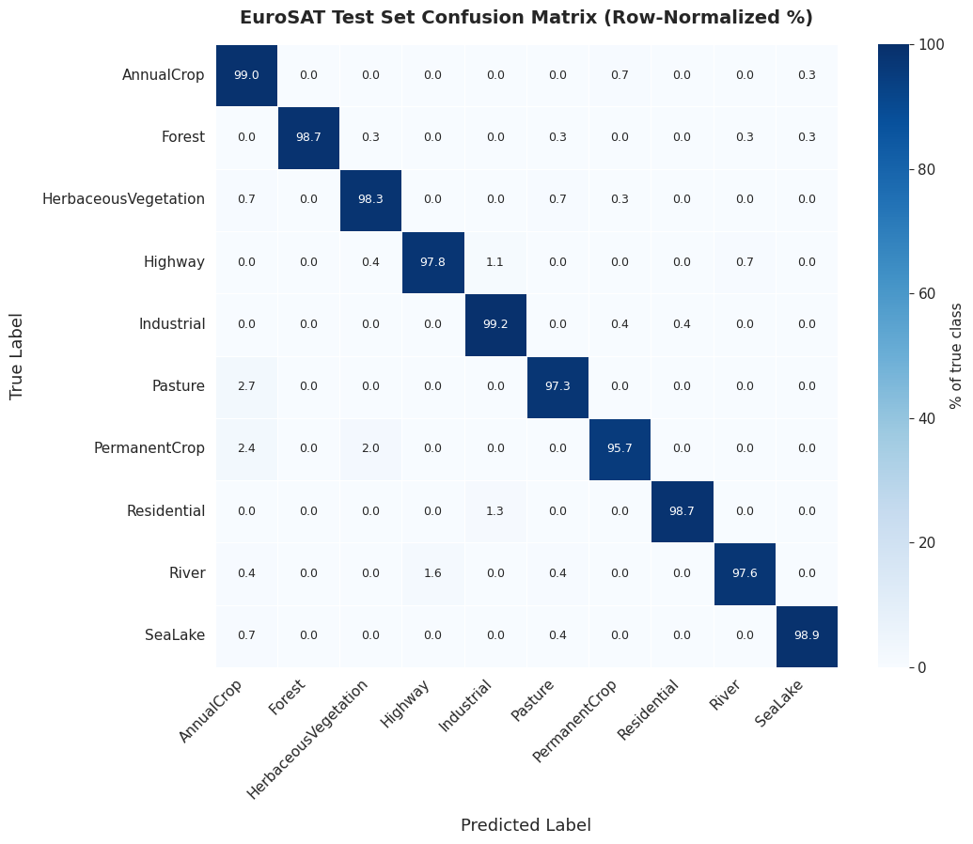

3.2 Application to Rondônia Imagery
Comparing the 2018 and 2024 composites by eye already showed a big, obvious change: a solid block of forest covering roughly the southern half of the 2018 image had turned into a fragmented patchwork of small cleared parcels by 2024.
When the model was run on this imagery, its predictions leaned heavily toward "SeaLake," covering 58.8% of sampled 2018 patches and 79.2% of 2024 patches, which is not plausible for a region with no water bodies anywhere near that size. Even with that problem, the Forest class on its own still moved in a sensible, consistent direction: 32.9% of sampled patches were Forest in 2018, dropping to 13.8% by 2024, matching what the composite images already showed.
Of the 1,102 sampled locations classified as Forest in 2018, 669 (60.7%) were classified differently by 2024. But 96.0% of those changed locations were reclassified specifically as SeaLake, not as any of the land-use categories you'd actually expect from real clearing, like AnnualCrop, Pasture, or Residential. That pattern points to the same SeaLake bias described above rather than a genuinely water-related change.
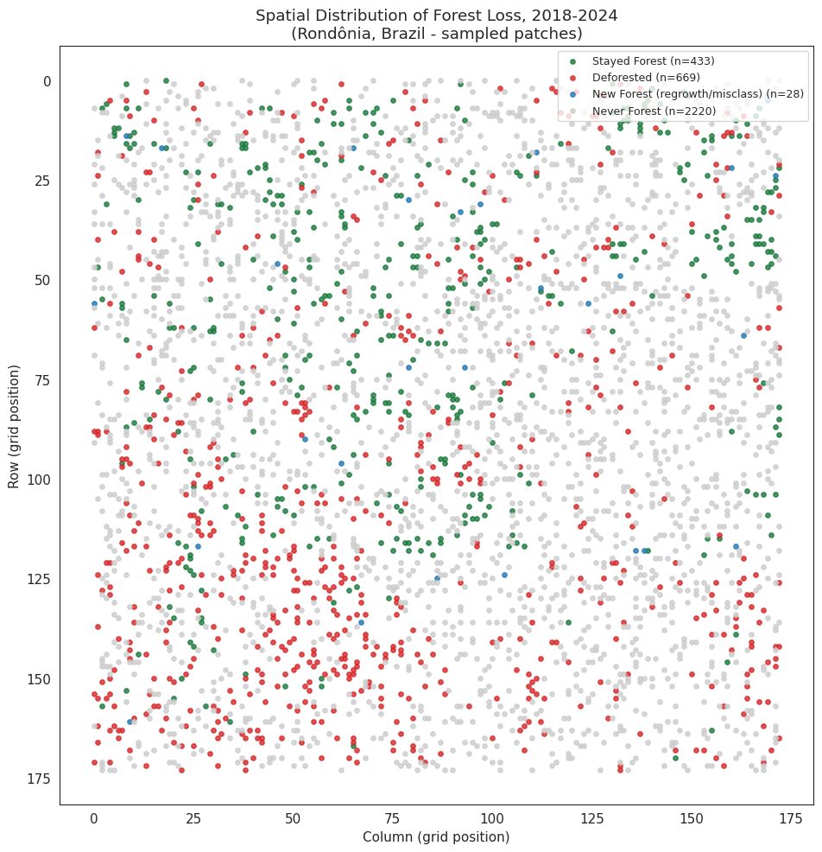

3.3 Comparison with Global Forest Watch
Global Forest Watch's Hansen-based data put forest loss for this area and period at 6.91%. Our model's raw output put it at 60.7%, about 8.8 times higher.

4. Discussion
The gap between the model's strong in-domain accuracy (98%) and its badly inflated deforestation estimate out of domain is large, but it isn't random noise. Almost all of the error traces back to one specific, identifiable mistake: the model kept calling cleared or pasture land "SeaLake." A likely explanation is that cleared land in this part of the Amazon has a spectral signature, smoother texture, different reflectance balance between soil and remaining vegetation, that the model had never seen during training on European imagery alone, and it ended up mapping that unfamiliar signal onto the closest thing it did know: water.
This matters beyond just this one project. A model's accuracy on its own test set doesn't tell you much about how it will behave somewhere new, and the failure can be severe and hard to catch. The model's own confidence scores gave no warning that these particular predictions were unreliable; only comparing against an outside data source revealed the problem.
At the same time, it's worth noting what actually held up here. The direction of the result, that real, substantial forest loss occurred in this region, was confirmed by the model, by Global Forest Watch, and by simply looking at the two images side by side. That suggests transfer learning from a dataset like EuroSAT can still pick up on genuine change even outside its training domain, even if its exact numbers can't be trusted without a check against something independent.

4.1 Limitations
A few limitations are worth being upfront about. The classifier only used RGB bands; the full 13-band Sentinel-2 data might have given the model enough extra information to tell cleared land apart from water, at the cost of a more complex pipeline. Computational limits meant only a random sample of patches was classified rather than the entire grid; the sampling method (fixed seed, same locations both years) avoids obvious spatial bias, but it still means the results describe a sample, not a complete map. Comparing only two years also can't separate a lasting land-cover change from a temporary one, like a seasonal shift in vegetation or a cloud-masking artifact, though restricting both years to the same dry-season window was meant to reduce that risk. Finally, only one independent source (Global Forest Watch) was used for validation; checking against a second source, such as Brazil's own PRODES monitoring program, would make the size of the discrepancy found here more convincing.

5. Conclusion
A ResNet50 model trained through transfer learning on EuroSAT reached 98% accuracy on its own European test set, but overestimated deforestation in the Brazilian Amazon by roughly 8.8 times compared to Global Forest Watch, almost entirely because it mistook cleared land for water. The underlying finding, that forest loss was occurring and occurring substantially, held up across every method used, including the model itself. The broader lesson is that domain shift is a real, first-order problem for satellite classifiers trained on curated regional datasets like EuroSAT, and that this gap has to be measured against independent data rather than assumed to be small. Future work could try fine-tuning on even a small amount of labeled tropical imagery, using the full multispectral bands instead of just RGB, and checking results against more than one independent data source.

References
Helber, P., Bischke, B., Dengel, A., & Borth, D. (2019). EuroSAT: A Novel Dataset and Deep Learning Benchmark for Land Use and Land Cover Classification. IEEE Journal of Selected Topics in Applied Earth Observations and Remote Sensing.
He, K., Zhang, X., Ren, S., & Sun, J. (2016). Deep Residual Learning for Image Recognition. Proceedings of the IEEE Conference on Computer Vision and Pattern Recognition (CVPR).
Hansen, M. C., Potapov, P. V., Moore, R., et al. (2013). High-Resolution Global Maps of 21st-Century Forest Cover Change. Science, 342(6160), 850-853.
Global Forest Watch. World Resources Institute. www.globalforestwatch.org
[Add any additional sources you used]

